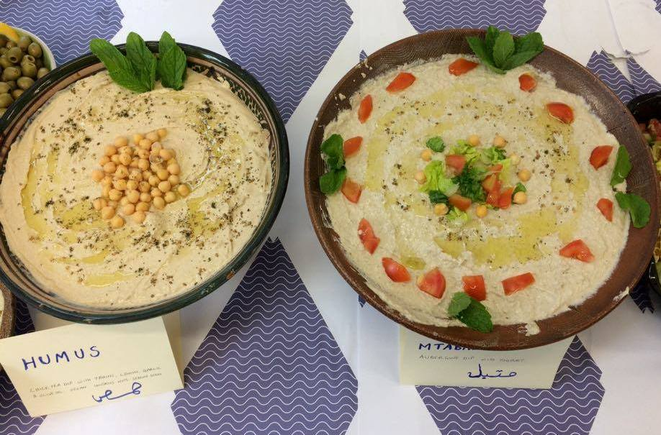
Arabic Café
Event Catering Menu

Cold Buffet choices include:

Hot Kurdish Lentil soup شوربة
with carrots, stock and herbs

Humus حمص
Chick pea dip, blended with tahini, lemon, garlic and olive oil (n)

Babaganoosh بابا غنوج
Aubergine dip with tomatoes, tahini, lemon, garlic, olive oil and herbs (n)

Mtabal متبل
Aubergine dip with yoghurt, tahini, lemon, garlic, olive oil and herbs (v) (n)

Flat Arabic bread or wraps خبز
Great for dipping

Taboula salad تبولة سلطة
with wheat, flat leaf parsley, tomato, dressed with lemon and olive oil

Salata سلطة
Arabic salad with chopped lettuce, tomato, cucumber, and a dressing of mint, lemon and olive oil

Olives (zaytoun) (n) زيتون

Notes: Cold buffet menu is all vegan except v = vegetarian. n = contains nuts. Please ask about allergens.
Hot buffet choices freshly cooked on-site.
Desserts (heluwat) حلويات

Baclava بقلاوة
Not balaclava! Layers of filo pastry filled with custard (v)

Basbousa بسبوسا
Sweet semolina cake, made with yoghurt and flour, topped with coconut (v) (n)

Madjoul Dates (tamer) تمر
Succulent dates from the Palestinian city of Jericho (contains stones)

Fresh Fruit (fakiha) فاكهة

Hot Buffet choices include:

Fresh Falafel wrap ساندويتش فلافل
Chick peas mixed with onion, garlic and herbs, in a wrap
Standard extras with falafel:
١ Salad tomato, cucumber, lettuce
٢ Talatour yoghurt sauce (n) تالاتور
٣ Pickled gherkins
٤ Hot chilli sauce الفلفل الحار

Chips (rakeek) رقائق
Chicken and rice dish
BBQ Chicken kebabs

Fresh flat bread (khubz) خبز
Smells great! Hand made with yeast, great for dipping or wrapping

Additional extras include:

- Full range of drinks including Arabic coffee and fresh mint tea
- Fair trade products of Palestine such as olive oil, za’atar and dates
- Individual portions
- Reusable crockery and cutlery
- Halal meat
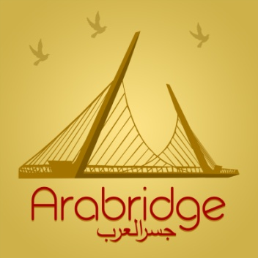
- People to serve
- Cleaning the serving area before and/or after

Arabridge
is a solidarity enterprise. We aim to help everyone integrate with Arabic speaking refugees and migrants.
In May 2016, a dozen families from war-torn Syria found a warm welcome in Derry-Londonderry. Some families are generously sharing Arabic food, language and culture. Buying from Arabridge directly helps to build bridges, strengthen communities, and sustain livelihoods with migrant and refugee people.

The Arabic Café delivers freshly prepared Arabic meals, snacks, desserts and drinks. Languages spoken include Arabic and Kurdish, plus some Turkish, Irish and Hebrew. As well as catering, we offer translation and interpretation, one to one lessons, language swaps and volunteer work experience. We also offer music, dance, singing and cultural workshops for all ages.

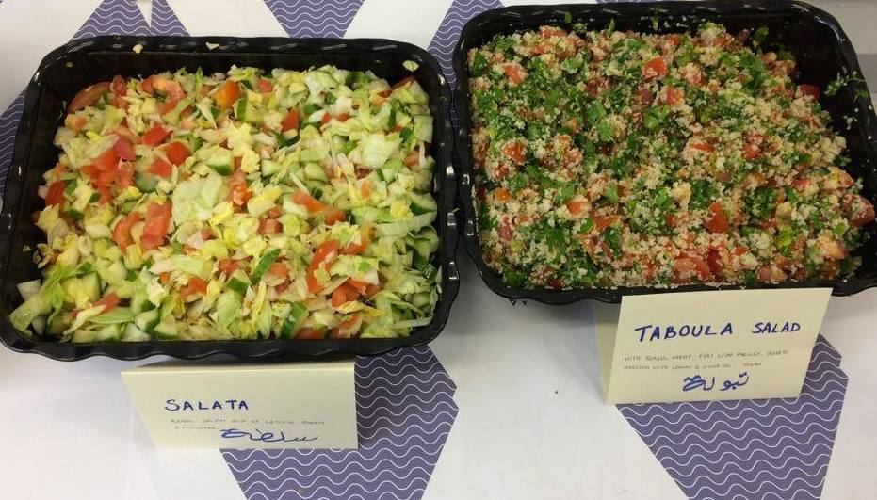
Contact: Pop into the Arabic café in the Nerve Centre on Thursdays ~
Text Jo Bird on 0797 007 5704 ~ Find Arabridge on Facebook ~ email: arabridgenorthwest@gmail.com

Updated 23 May 2017

