Dhammaan 6-da Kulleej ee Waxbarashada Dheeraadka ah ee Northern Ireland waxay bixiyaan koorsooyin ESOL ah oo la aqoonsan yahay.
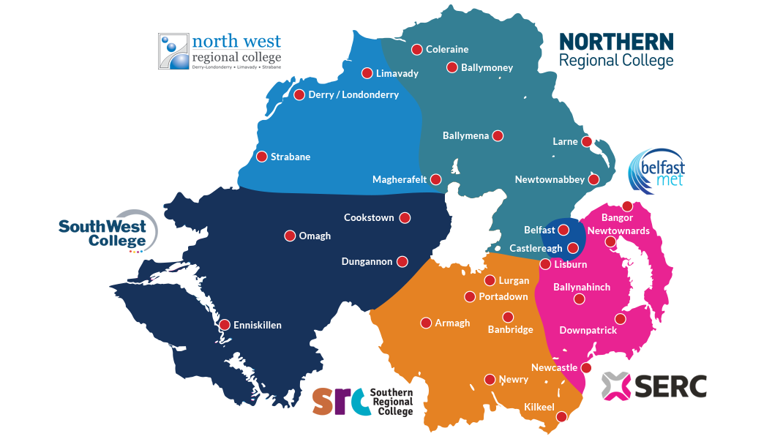

Koorsooyinka Ingiriisiga ee Dadka ku hadla Luuqadaha Kale (English for Speakers of Other Languages) (ESOL) ee ay bixiyaan Kulleejyada Waxbarashada Dheeraadka ah ee Northern Ireland waa u bilaash qaxootiga, magangalyo-doonka iyo qaybaha kale ee gaarka ah ee soo-galootiga.
Fadlan ka eeg linkiga hoose Kulleejka ku yaalla aaggaaga:
Belfast Met - Qiimaynta iyo Diiwaangelinta ESOL (belfastmet.ac.uk)
Belfast Met waxay furtay qaadashadeedii ugu dambeeysay 14^{kii} Agoosto 2024 saacadu markay ahayd 2pm. Markay ahayd 2.15pm dhammaan boosaskii qiimaynta ee bannaanaa way buuxsameen maadaama baahida codsiyada ay aad uga sarraysay awoodda kulleejyada.
Belfast Met waxay horey u xaqiijisay ku dhawaad 1450 dib-u-diiwaangelineed oo loogu talagalay ardayda ESOL si ay u sii wataan waxbarashadooda inta lagu jiro sanad-dugsiyeedkan soo socda (24-25) xitaa ka hor inta aan loo furin 250 boos oo dheeraad ah ardayda cusub 14^{ka} Agoosto.
Haddii aadan awoodin inaad hesho diiwaangelinta qiimeynta iyo diiwaangelinta Belfast Met, waxaad tixgelin kartaa ikhtiyaaro kale oo ah kulleejyada kuu dhow sida Lisburn, Bangor (SERC) ama Newtownabbey (NRC).
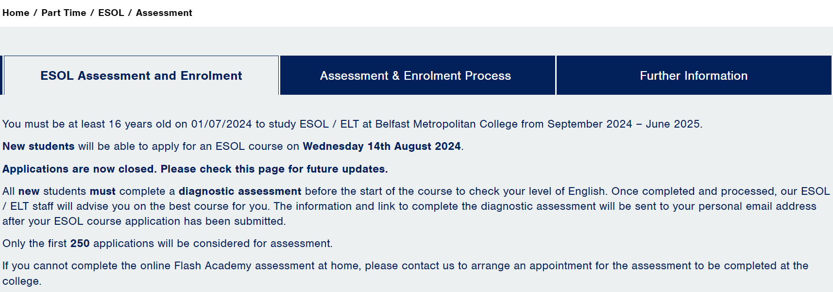
Hoos ka eeg sida loo codsado qiimaynta Kulleejyada kale ee FE iyo linkiga habka codsiga:
South Eastern Regional College (SERC) - ESOL - SERC
Xagga hoose ee bogga kor lagu tilmaamay, waxaad ka heli doontaa linkiga goobaha kala duwan ee kambasyada.
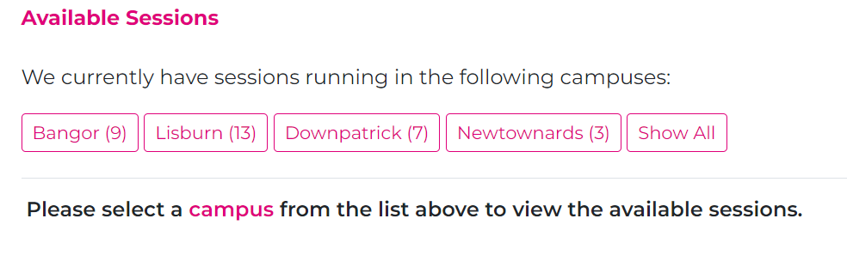
Marka aad doorato koorsada aadka kuugu habboon ee ku qoran websaydhka, fadlan dooro ikhtiyaarka 'Apply Now'.

Fadlan ogow in fasallada ESOL ay bilaash u yihiin qaxootiga, magangelyo-doonka iyo muhaajiriinta dib loo dejiyay ee Afghanistan ama Ukrain ee Northern Ireland, markaa ha ku niyad-jabin khidmadaha ku qoran websaydhka.
Waxaad u baahan doontaa inaad koonto iyo fure sireed ku sameysato kulleejka (SERC) marka aad gujiso ‘Continue’ codsiga.
SERC waxay ku bixisaa koorsooyinka ESOL Lisburn, Bangor, Downpatrick iyo Newtownards.
Qaar ka mid ah goobahan ayaa si fudud looga aadi karaa Belfast iyada oo la adeegsanayo tareen ama adeegyada baska.
Haddii kale, waxaad la xidhiidhi kartaa admissions@serc.ac.uk oo aad wax ka waydiin kartaa daneynta aad u leedahay inaad codsato fasallada ESOL.
SERC waxay haysataa fiid is-diiwaangelineed Nis-Galin ah 29^{ka}Agoosto, oo ay ku jiraan fursadaha lagu ogaanayo wax badan oo ku saabsan fasallada ESOL si shakhsi ahaaneed. Faahfaahinta iyo linkiga hoose ka eeg macluumaad dheeraad ah:
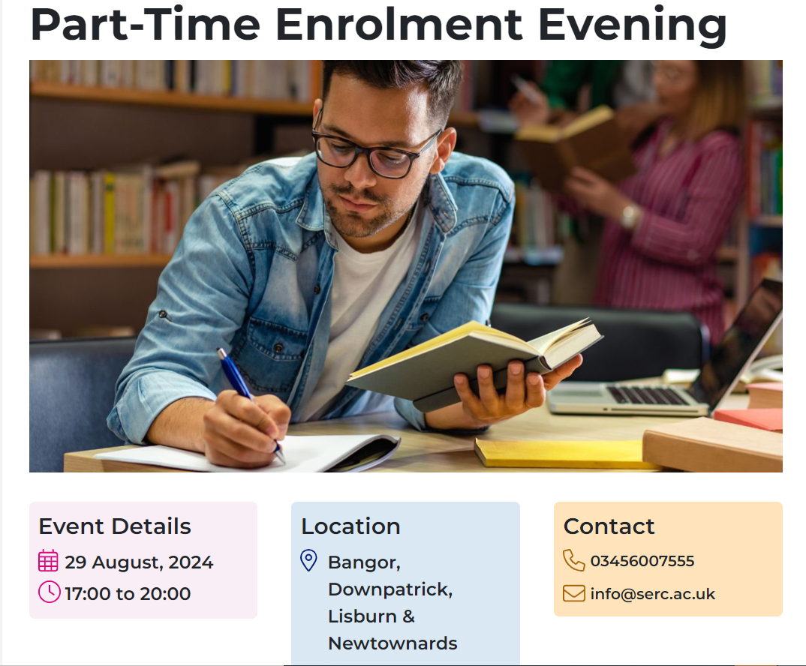 linkiga websaydhka: https://www.serc.ac.uk/event/PT-Enrolment-Aug-24
Northern Regional College (NRC) - Natiijooyinka Raadinta | NRC Northern Regional College
Northern Regional College waxay sidoo kale ku bixisaa koorsooyinka ESOL kambasyadooda ku yaalla Newtownabbey, Magherafelt, Coleraine, Antrim iyo Ballymena.
Markaad gujiso linkiga kore, waxaad ka heli doontaa dhammaan koorsooyinka soo socda oo diyaar ah oo billaabmi doona laga billaabo 16^{ka} Sebteembar 2024 wixii ka dambeeya.
Waxaad ka heli doontaa liis koorsooyin ah oo laga heli karo mid kasta oo ka mid ah kambaska kulleejka, tusaale ahaan:
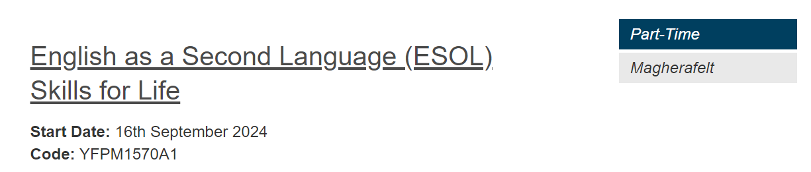
Guji cinwaanka koorsada ee goobta aad door bidayso oo dooro badhanka cas ee ah ‘Apply Now’.
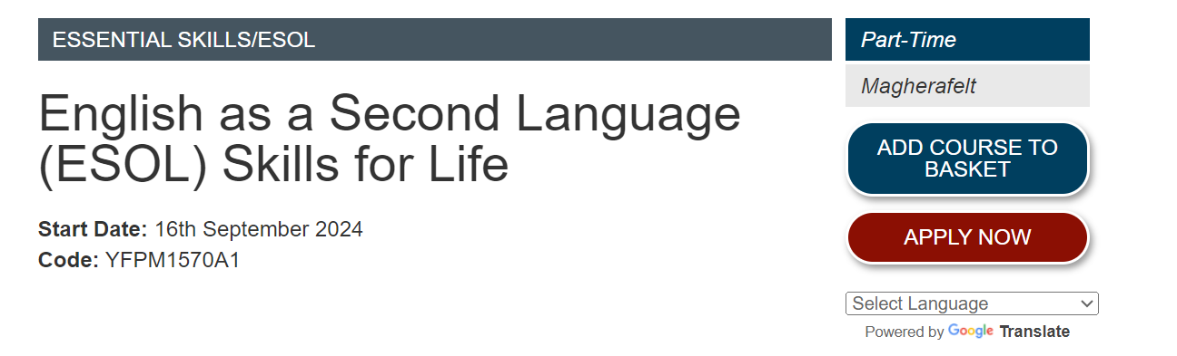
Waxaad ku turjumi kartaa bogga adigoo isticmaalaya habka tarjumaadda google-ka ee lagu muujiyay hoosta badhanka cas ee ‘Apply Now’.
Southern Regional College (SRC) - Koorsooyinka | Southern Regional College (src.ac.uk)
Fadlan, sidoo kale hoos ka eeg faahfaahinnada sida la'isaga diiwaangeliyo fasallada ESOL ee SRC (Lurgan/Portadown/Armagh/ Craigavon/Newry iyo Banbridge):
Markaad gujiso linkiga kore, waxaad ka heli doontaa dhowr koorsooyin oo ESOL ah oo laga heli karo goobaha kala duwan:
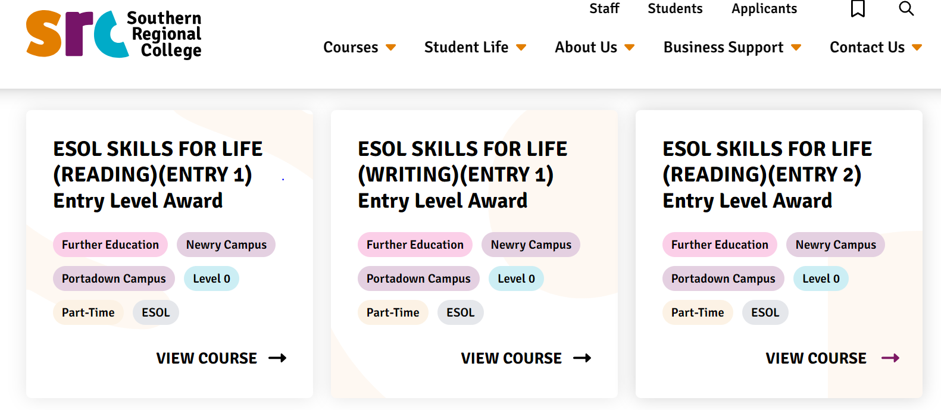

Si loogu biiro fasallada ESOL ee SRC, dhammaan ardaydu waa inay ka qayb-galaan kulanka la-talinta ka hor is-diiwaangelinta (PEAS) ka hor intaysan isku diiwaangelin koorso ESOL ah. Waxaad faahfaahintaada kaga dari kartaa liiska sugitaanka halkan hoose:
· Liiska Sugitaanka: https://forms.office.com/r/cUJp5KiHpm

South West College (SWC) - ESOL | South West College (swc.ac.uk)
Wixii macluumaad dheeraad ah ama si aad u diiwaangeliso daneyntaada fadlan la xidhiidh xubin ka tirsan kooxdeena:
Xidhiidhada
- Kathryn.Hart@swc.ac.uk - Cookstown Campus iyo Dungannon Campus
- Isabel.Arrayas@swc.ac.uk - Enniskillen Campus iyo Omagh Campus
Fasallada Sebteembar 2024 Taariikhaheena Diiwaangelinta waa sidan soo socota:

Cookstown Campus: (Isku dhafka maalmaha qiimaynta iyo isdiiwaangelinta) Isniin 2-da Sebteembar 10:00am-12:00pm & 5:30pm-8:00pm. Lacag bixin buuxda iyo aqoonsi sawir leh (oo wata macluumaadka fiisaha haddii ay khusayso) ayaa loo baahan yahay wakhtiga codsiga.

Dungannon Campus (Isku dhafka maalmaha qiimaynta iyo isdiiwaangelinta) Khamiis 29-ka Agoosto 09:30am-12:30pm. Isniin 9-ka Sebteembar 5:30pm-8:00pm. Arbaco 11-ka Sebtembar 5:00pm-8:00pm. Lacag bixin buuxda iyo aqoonsi sawir leh (oo wata macluumaadka fiisaha haddii ay khusayso) ayaa loo baahan yahay wakhtiga codsiga.
Enniskillen Campus (maalmaha Qiimaynta oo kaliya) Arbaco 28-da Agoosto 09:30am-1:30pm. Khamiis 29-ka Agoosto 1:00pm-4:00pm.
Enniskillen Campus (maalmaha Isdiiwaangelinta oo keliya) Isniin 9-ka Sebteembar 5.00pm-8:00pm. Arbaco 11-ka Sebtembar 5:00pm-8:00pm. Lacag bixin buuxda iyo aqoonsi sawir leh (oo wata macluumaadka fiisaha haddii ay khusayso) ayaa loo baahan yahay wakhtiga diiwaangelinta.
Omagh Campus (maalinta Qiimaynta oo kaliya) Talaado 27-da Agoosto 1:00pm-4:00pm. Isniin 2-da Sebteembar 09:30am-1:30pm.
Omagh Campus (maalinta Isdiiwaangelinta kaliya) Talaado 10-ka Sebteembar 5:30pm-8:00pm. Isniin 16-ka Sebteembar 5:30pm-8:00pm. Lacag-bixin buuxda iyo aqoonsi sawir leh (oo wata macluumaadka fiisaha haddii ay khusayso) ayaa loo baahan yahay wakhtiga diiwaangelinta

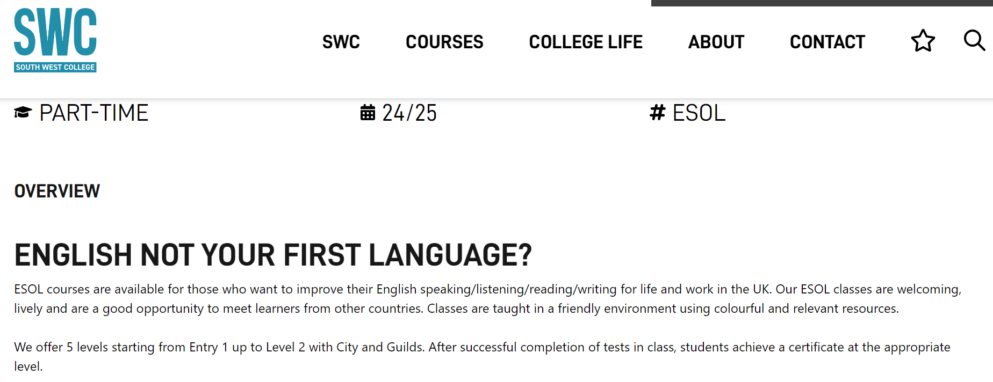
North West Regional College (NWRC) - Ingiriisiga Dadka Ku Hadla Luuqadaha Kale (ESOL) | North West Regional College (nwrc.ac.uk)
Si aad isaga diiwaangeliso fasallada ESOL aagga Kambaska Derry/Londonderry, fadlan buuxi foomka sida ku qoran linkiga hoose:
https://forms.office.com/Pages/ResponsePage.aspx?id=byooLPyglkWczCN48bTPHscT9CQTJoVGuy4h0Ax1Q1ZUNFBLMENIRFBBSFBMOFZTQ0lSWjBMUzZaSy4u
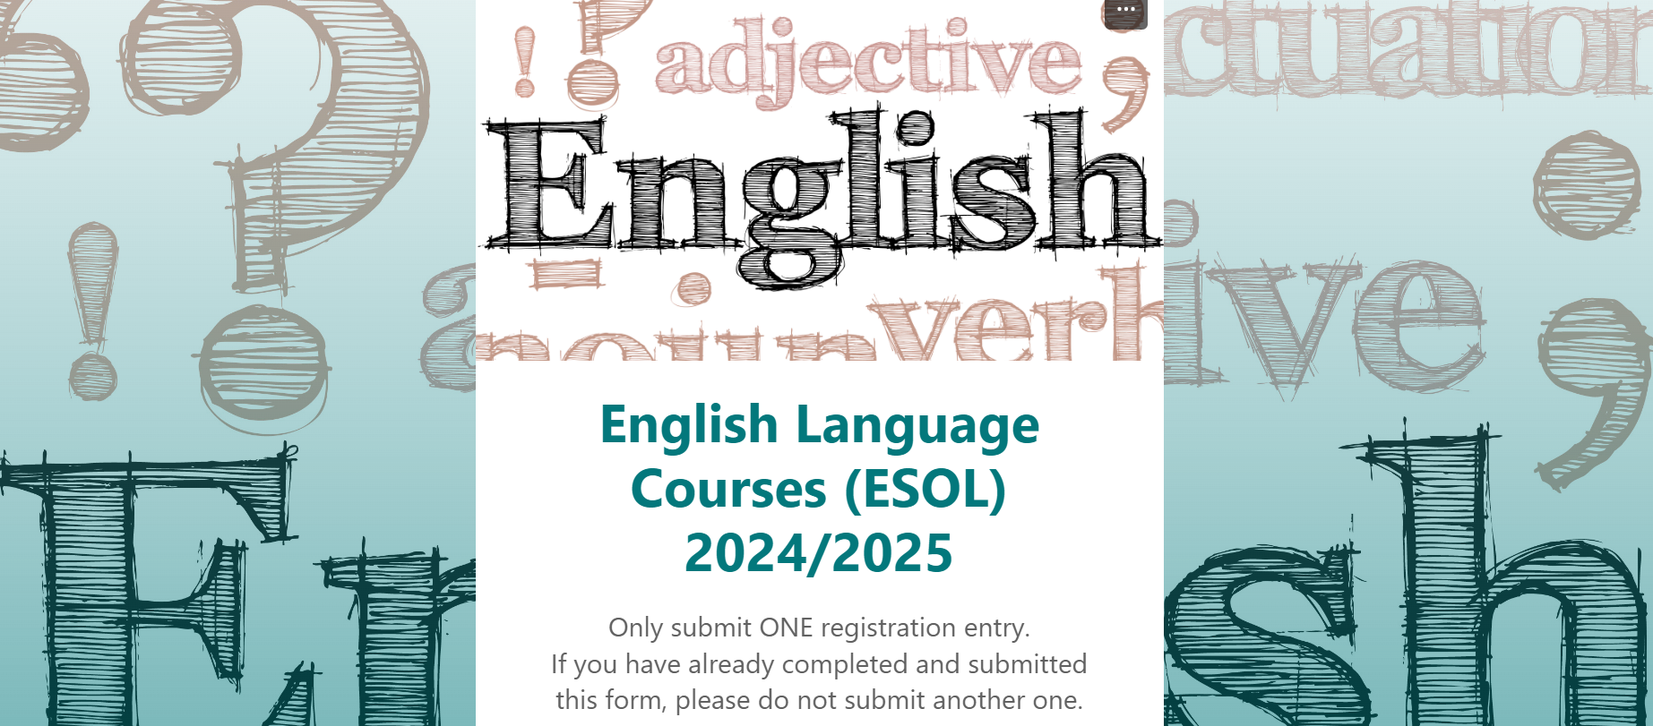

Fursadda koorsooyinka bilaashka ah ee onleenka ah:
Inta aad sugayso qiimayntaada, maxaadan u hubineyn mid ka mid ah afarta koorso ee onleenka ah ee Kulleejka SRC ee loo sameeyay qayb ka mid ah Mashruuca BRIDGES:
· Mashruuca BRIDGES - Bey'ada Waxbarashada

Fasallada Bulshada:
Bixiyeyaasha bulshada iyo dugsiyada gaarka loo leeyahay waxay sidoo kale ka bixiyaan fasallada ESOL guud ahaan Northern Ireland oo dhan waxaadna, adigoo u maraya websaydhkan , ka raadin kartaa luuqadda Ingiriisiga oo dheeraad ah oo laga bixiyo agagaarkaaga. Inta badan fasallada bilaashka ah ee lagu bixiyo qaabka bulshada dhexdeeda , waxaa heli kara oo keliya dadka waaweyn (ka weyn da'da 18).
Waxbarashada Dheeraadka ah ee helitaanka ESOL ee ay bixiyaan kulleejyada ayaa u adeegi kara qof kasta oo ka weyn da'da 16 (iyadoo ku xiran boosaska bannaan).
Ka raadinta bixiyeyaasha tababarka luuqadda Ingiriisiga iyo koorsooyinka websaydhka ESOL NI:
ESOL NI (esolwebapp.azurewebsites.net)

Isla boggan internetka, waxaad ka heli doontaa sanduuqa raadinta iyo ikhtiyaaro kala duwan.
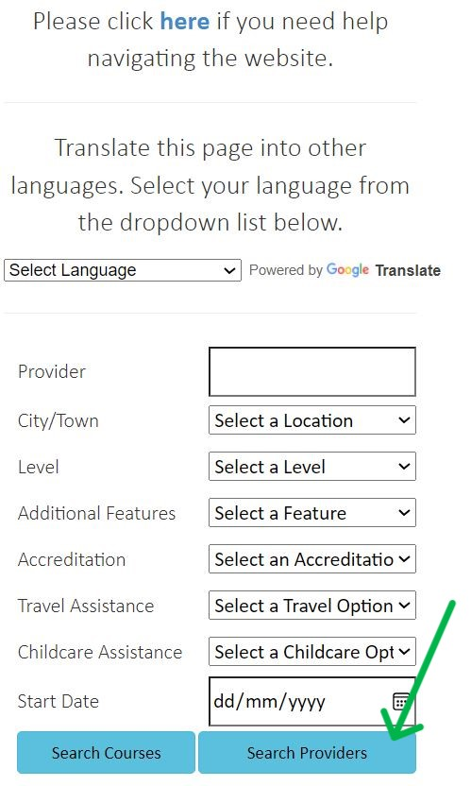
Waxaan kugula talineynaa inaad ku billowdo raadintaada adiga oo dooranaya 'Caasimadda/Magaalada' kadibna hoos ugu dhaadhacaya ikhtiyaarada jira. Dooro goobta ku dhow meesha aad ku nooshahay.
Si aad u gaadho natiijada ballaadhan ee suurtogalka u ah goob kasta, waa inaad si toos ah u gujisaa badhanka buluuga ah ee loo yaqaan ‘Search Providers’.
HA ISKU DAYIN 'Searching Courses' sababtoo ah bixiyeyaasha halkan ku taxan qaarkood si joogto ah uma cusboonaysiiyaan tafaasiisha koorsadooda natiijadana waxaa laga yaabaa inaysan soo bixin.
Haddii aad rabto in aad u turjunto websaydhka luuqad kale waxaad ka heli doontaa sifadan ka hoosaysa calaamadda ESOL NI oo wax yar ka sarraysa goobaha raadinta, ee ah dhanka midig ee shaashadda.
